SMART EVENT MANAGEMENT SYSTEM

A course project report submitted in partial fulfilment of the requirement
of

DEVOPS AND FULLSTACK
by

B.SANJANA (2303A52306)
M.SANJANA (2303A52292)

Under the guidance of
Dr. N.VENKATESH
Asst. Professor, Department of CS & AI



SR University, Warangal APRIL-2026

ABSTRACT

The Smart Event Management System is a full-stack web application designed to simplify event discovery, personalized recommendations, and user networking. The system includes a secure login page for user authentication, allowing users to create accounts and access personalized features.
The platform enables users to explore various events based on their interests and preferences through an interactive and user-friendly interface. A unique feature of the system is its mood-based event recommendation, where events are suggested according to the user’s current mood, enhancing personalization and user engagement.
Another innovative feature is the Match Maker module, which helps users find and connect with people who share similar interests. This feature creates opportunities for networking, collaboration, and social interaction by recommending like-minded individuals and allowing users to connect with them.
The project was developed using React, HTML, and CSS for the frontend, providing a responsive and modern user interface, while Node.js and Express.js were used for the backend to handle server-side logic, routing, and data management. As a full-stack application, the system demonstrates effective integration of frontend and backend technologies to deliver a seamless user experience.

INTRODUCTION

About the Project
The Smart Event Management System is a full-stack web application developed to help users discover and connect with events and people of similar interests. The system provides secure login, event exploration, and mood-based recommendations.
It also includes a match-making feature to connect like-minded individuals. The project is built using React, HTML, CSS, Node.js, and Express.js.
The application includes:
    - Login page with authentication
    - Explore events by category
    - Mood-based event recommendations
    - Matchmaker to connect with similar interests
    - User profile management

Objectives
    - To develop a user-friendly platform for event discovery and management.
    - To provide personalized event recommendations based on user mood.
    - To help users find people with similar interests.
    - To enable users to connect and interact with like-minded individuals.
    - To implement a full-stack web application using modern technologies.

CONTENTS
ABSTRACT ii
Chapter No. Title Page No.
- INTRODUCTION 01
  - About the project 01
  - Objectives 02
- LITERATURE REVIEW
  - Overview 03
  - Related Studies and Existing Solutions 05
  - Tools and Technologies Used 07
- METHODOLOGY
  - Data Collection and Description 08
  - Data Preprocessing and Cleaning 10
  - Analytical and Visualization Techniques 12
- RESULTS AND DISCUSSION
  - Data Analysis and Key Findings 14
  - Visualization and Interpretation of Results 16
  - Insights and Discussion 18
- CONCLUSION AND FUTURE WORK
  - Summary of Findings 19
  - Conclusions Drawn 20
  - Recommendations and Future Scope 20

CHAPTER 2: LITERATURE REVIEW

DevOps and Full-Stack Application Development

Modern event management platforms have moved from manual coordination to digital solutions that emphasize scalability and user engagement. Full-stack development practices, supported by frontend frameworks like React and backend technologies such as Node.js and Express, enable dynamic interfaces and robust APIs. Databases like MongoDB or PostgreSQL provide flexible storage, while authentication systems ensure secure access. Integrating DevOps with full-stack systems improves performance and accessibility, making these technologies central to modern event platforms.
Recent studies highlight personalization and social networking as key factors in enhancing event participation. Recommendation engines improve engagement but often rely on static filters rather than adaptive suggestions. Matchmaking features are common in networking apps but underutilized in event systems.
Your project addresses this gap by combining mood-based event recommendations with interest-driven matchmaking, offering both emotional personalization and community building. This positions your Smart Event Management System as an innovative solution beyond conventional event management.

METHODOLOGY

System Architecture

The application follows a client-server architecture:

    - Frontend: React, HTML, CSS, JavaScript

    - Backend: Node.js + Express

    - Database: MongoDB

Data Handling

    - User data stored securely in MongoDB

    - Passwords hashed using bcrypt for security

    - JWT (JSON Web Token) used for authentication and session management

Functional Modules

    - User Authentication: Signup, login, and secure access

    - Event Exploration: Browse and filter events by category

    - Mood-Based Recommendations: Suggest events based on user’s emotional state
    - Matchmaker Module: Connect users with similar interests

    - User Profile Management: Save preferences and track activity

Deployment & Scalability

    - Hosted on cloud platforms for scalability

    - Continuous integration and deployment pipelines for faster updates

RESULTS AND DISCUSSION

Implementation Results
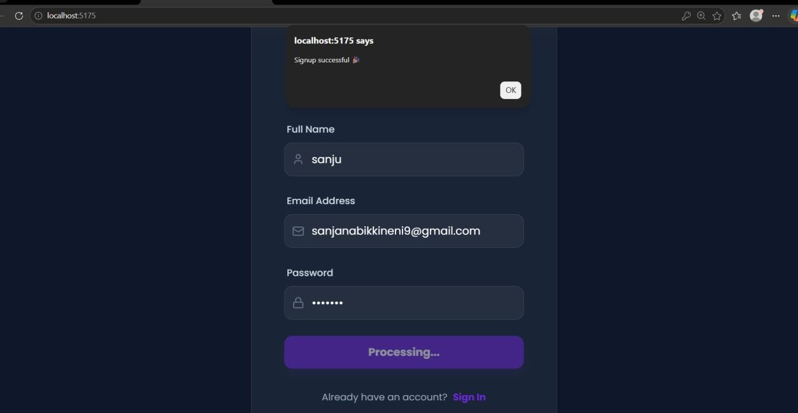

SIGNUP SUCCESSFUL
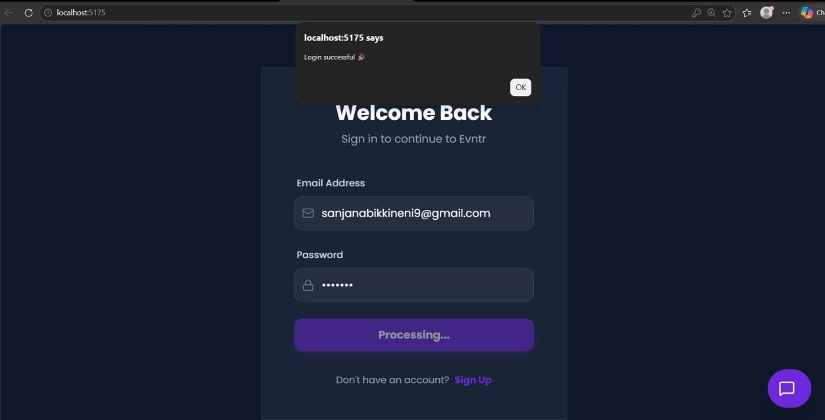

LOGIN SUCCESSFUL

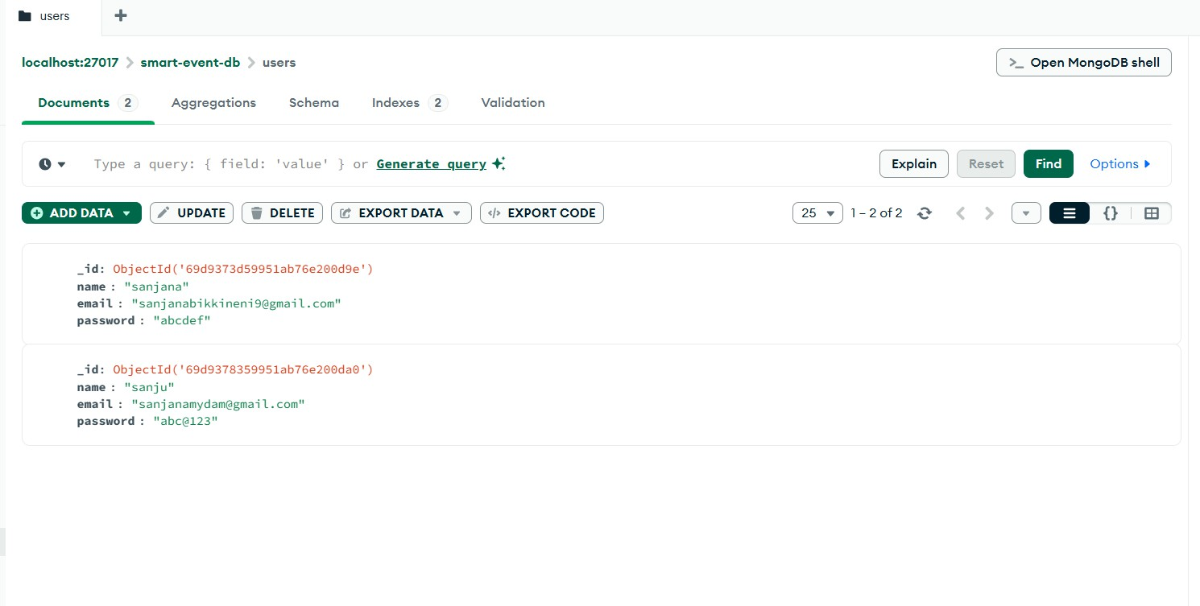

BACKEND CONNECTED TO MONGODB
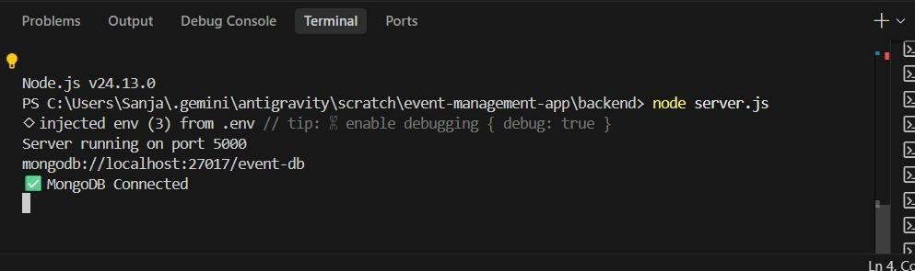

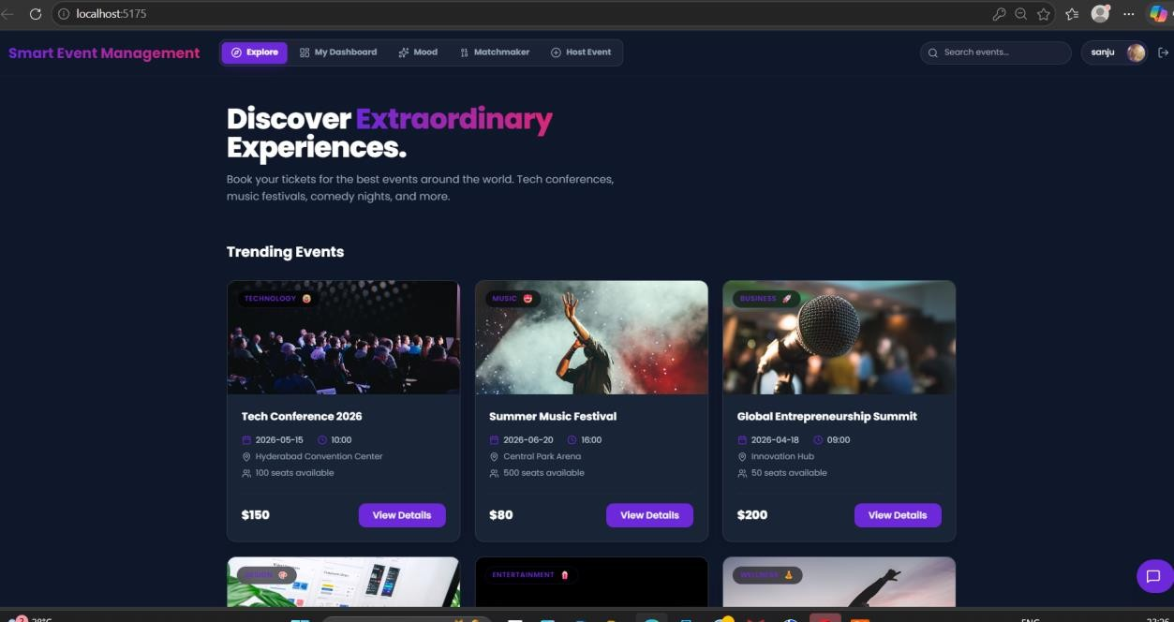

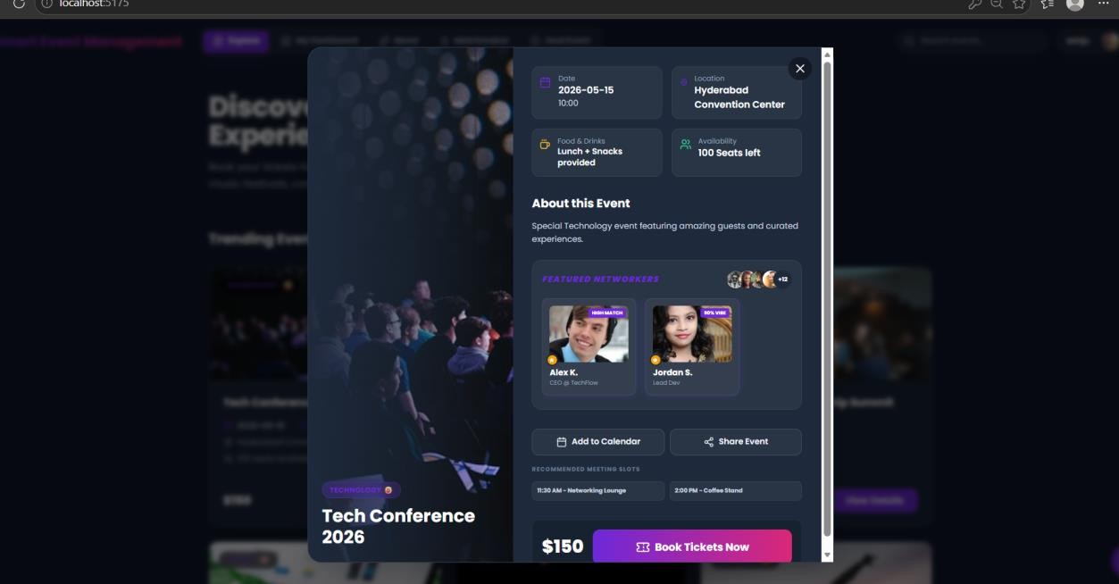

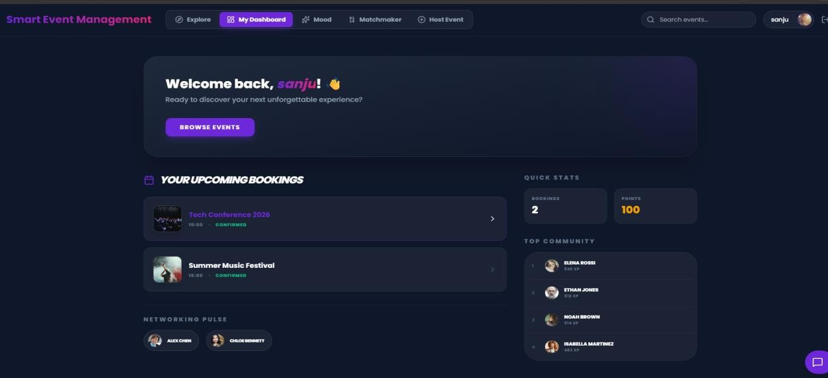

MOOD BASED EVENT RECOMMENDATION
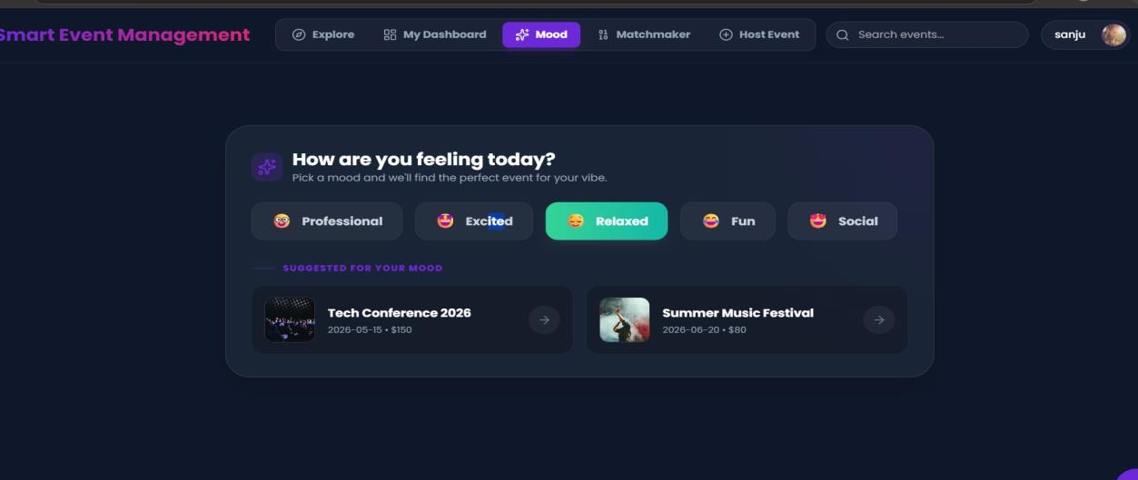
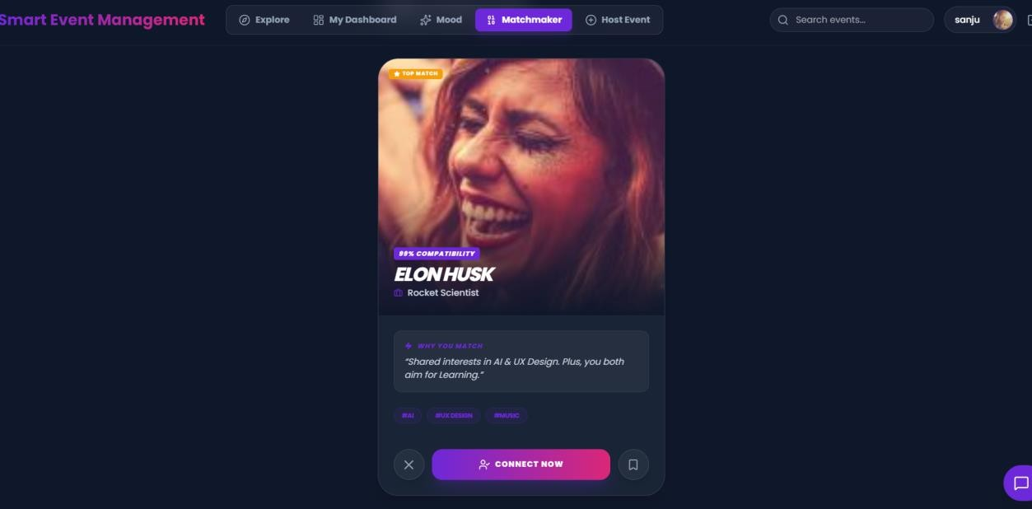

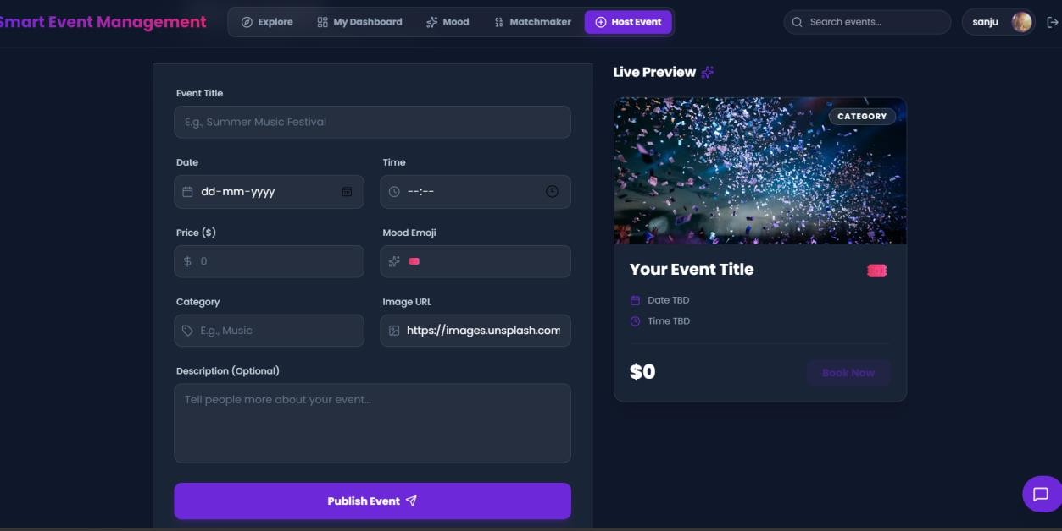

Key Features Achieved

    - User Authentication & Login System

    - Event Browsing & Exploration

    - Event Booking & Registration

    - Admin Event Management

Discussion

The Smart Event Management System was successfully developed to simplify the process of organizing and managing events. The system provides a user-friendly interface for users to register, log in, explore available events, and book them easily. It also supports efficient event management through admin functionalities such as adding, updating, and deleting event details. Overall, the project improved accessibility, reduced manual effort, and demonstrated the practical use of full-stack web development technologies in solving real-world event management challenges.

CONCLUSION AND FUTURE WORK

  - Conclusion

The Smart Event Management System was successfully designed and developed to provide an efficient and user-friendly platform for managing events. The project simplifies tasks such as user registration, event browsing, and booking, while also enabling administrators to manage event details effectively. It demonstrates the practical implementation of full-stack web development concepts and helps reduce manual effort in event organization.

Future Scope

The future scope of the Smart Event Management System includes integrating secure online payment gateways for easy event booking and ticket confirmation. The system can be enhanced with real-time notifications through email or SMS to keep users updated about event schedules and reminders. Advanced features such as AI-based event recommendations and seat availability tracking can improve the user experience. Additionally, developing a mobile application with QR-based entry and digital passes can make the system more accessible and efficient.

